|  |
| --- |
| India General Elections 2024 Results Analysis |
| **Total Seats** |
| select distinct COUNT (parliament_constituency) as Total_seats from constituencywise_results |
|  |
| |  | | --- | |  | |  |
|  |  |
| **Total number of seats available for elections in each state** |  |
| select states.State, COUNT(constituencywise_results.Parliament_Constituency) as Total_Seats from states join statewise_results on states.State_ID = statewise_results.State_ID join constituencywise_results on constituencywise_results.Parliament_Constituency = statewise_results.Parliament_Constituency group by states.State |  |
|  |
| |  | | --- | |  | |  |
|  |  |
| **Total seats won by NDA Alliance** |  |
|  |  |
| select  SUM(case  when party in ('Bharatiya Janata Party - BJP',  'Telugu Desam - TDP',  'Janata Dal (United) - JD(U)',  'Shiv Sena - SHS',  'AJSU Party - AJSUP',  'Apna Dal (Soneylal) - ADAL',  'Asom Gana Parishad - AGP',  'Hindustani Awam Morcha (Secular) - HAMS',  'Janasena Party - JnP',  'Janata Dal (Secular) - JD(S)',  'Lok Janshakti Party(Ram Vilas) - LJPRV',  'Nationalist Congress Party - NCP',  'Rashtriya Lok Dal - RLD',  'Sikkim Krantikari Morcha - SKM')  then [won]  else 0  end) as Total_Seats_Won_by_NDA  from partywise_results |  |
|  |  |
| **Seats Won by NDA Allianz Parties** |  |
|  |  |
|  |  |
| select Party, Won from [partywise_results] where party in ('Bharatiya Janata Party - BJP',   'Telugu Desam - TDP',   'Janata Dal (United) - JD(U)',  'Shiv Sena - SHS',   'AJSU Party - AJSUP',   'Apna Dal (Soneylal) - ADAL',   'Asom Gana Parishad - AGP',  'Hindustani Awam Morcha (Secular) - HAMS',   'Janasena Party - JnP',   'Janata Dal (Secular) - JD(S)',  'Lok Janshakti Party(Ram Vilas) - LJPRV',   'Nationalist Congress Party - NCP',  'Rashtriya Lok Dal - RLD',   'Sikkim Krantikari Morcha - SKM') order by Won desc    **Total Seats Won by I.N.D.I.A. Allianz**  select SUM(case  when  party in('Indian National Congress - INC',  'Aam Aadmi Party - AAAP',  'All India Trinamool Congress - AITC',  'Bharat Adivasi Party - BHRTADVSIP',  'Communist Party of India (Marxist) - CPI(M)',  'Communist Party of India (Marxist-Leninist) (Liberation) - CPI(ML)(L)',  'Communist Party of India - CPI',  'Dravida Munnetra Kazhagam - DMK',  'Indian Union Muslim League - IUML',  'Nat`Jammu & Kashmir National Conference - JKN',  'Jharkhand Mukti Morcha - JMM',  'Jammu & Kashmir National Conference - JKN',  'Kerala Congress - KEC',  'Marumalarchi Dravida Munnetra Kazhagam - MDMK',  'Nationalist Congress Party Sharadchandra Pawar - NCPSP',  'Rashtriya Janata Dal - RJD',  'Rashtriya Loktantrik Party - RLTP',  'Revolutionary Socialist Party - RSP',  'Samajwadi Party - SP',  'Shiv Sena (Uddhav Balasaheb Thackrey) - SHSUBT',  'Viduthalai Chiruthaigal Katchi - VCK')  then [Won]  else 0  end) as Total_seats_won_by_INDIA_Allianz  from partywise_results |  |
|  |  |
|  |  |
| **Seats Won by I.N.D.I.A. Allianz Parties** |  |
|  |  |
| select Party, Won from partywise_results  where  party in('Indian National Congress - INC',  'Aam Aadmi Party - AAAP',  'All India Trinamool Congress - AITC',  'Bharat Adivasi Party - BHRTADVSIP',  'Communist Party of India (Marxist) - CPI(M)',  'Communist Party of India (Marxist-Leninist) (Liberation) - CPI(ML)(L)',  'Communist Party of India - CPI',  'Dravida Munnetra Kazhagam - DMK',  'Indian Union Muslim League - IUM  'Nat`Jammu & Kashmir National Conference - JKN',  'Jharkhand Mukti Morcha - JMM',  'Jammu & Kashmir National Conference - JKN',  'Kerala Congress - KEC',  'Marumalarchi Dravida Munnetra Kazhagam - MDMK',  'Nationalist Congress Party Sharadchandra Pawar - NCPSP',  'Rashtriya Janata Dal - RJD',  'Rashtriya Loktantrik Party - RLTP',  'Revolutionary Socialist Party - RSP',  'Samajwadi Party - SP',  'Shiv Sena (Uddhav Balasaheb Thackrey) - SHSUBT',  'Viduthalai Chiruthaigal Katchi - VCK')  order by Won desc |  |
|  |  |
|  |  |
|  |  |
|  |  |
|  |
| |  | | --- | |  | |  |
| **Add new column field in table partywise_results to get the Party Allianz as NDA, I.N.D.I.A and OTHER** |  |

alter table partywise_results  
add Party_Allianz varchar(150)  
  
update partywise_results  
set Party_Allianz = 'I.N.D.I.A.'  
where Party in ('Indian National Congress - INC',  
 'Aam Aadmi Party - AAAP',  
 'All India Trinamool Congress - AITC',  
 'Bharat Adivasi Party - BHRTADVSIP',  
 'Communist Party of India (Marxist) - CPI(M)',  
 'Communist Party of India (Marxist-Leninist) (Liberation) - CPI(ML)(L)',  
 'Communist Party of India - CPI',  
 'Dravida Munnetra Kazhagam - DMK',  
 'Indian Union Muslim League - IUML',  
 'Nat`Jammu & Kashmir National Conference - JKN',  
 'Jharkhand Mukti Morcha - JMM',  
 'Jammu & Kashmir National Conference - JKN',  
 'Kerala Congress - KEC',  
 'Marumalarchi Dravida Munnetra Kazhagam - MDMK',  
 'Nationalist Congress Party Sharadchandra Pawar - NCPSP',  
 'Rashtriya Janata Dal - RJD',  
 'Rashtriya Loktantrik Party - RLTP',  
 'Revolutionary Socialist Party - RSP',  
 'Samajwadi Party - SP',  
 'Shiv Sena (Uddhav Balasaheb Thackrey) - SHSUBT',  
 'Viduthalai Chiruthaigal Katchi - VCK')

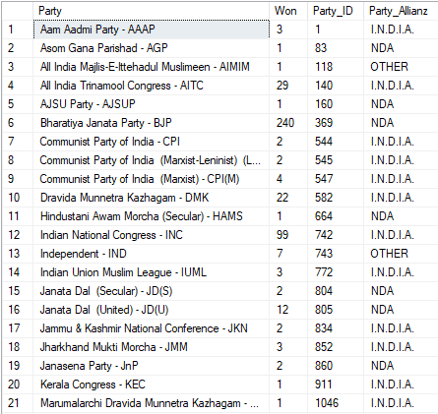

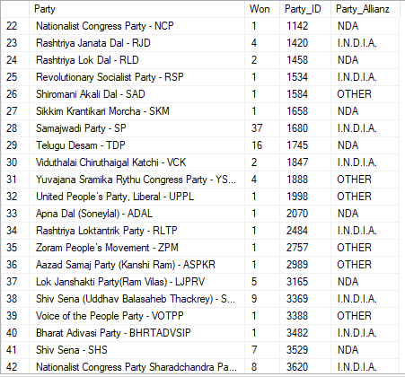

**Which party alliance (NDA, I.N.D.I.A, or OTHER) won the most seats across all states**

select Party_Allianz, SUM(Won) as Total_seats

from partywise_results

group by Party_Allianz

order by Total_seats desc

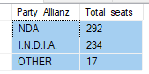

**Winning candidate's name, their party name, total votes, and the margin of victory for a specific state/constituency**

select Winning_Candidate, Party, Total_Votes, Party_Allianz, Constituency_Name, statewise_results.State

from constituencywise_results

join statewise_results

on constituencywise_results.Parliament_Constituency = statewise_results.Parliament_Constituency

join partywise_results

on partywise_results.Party_ID = constituencywise_results.Party_ID

join states

on states.State_ID = statewise_results.State_ID

where Constituency_Name = 'Agra'



**Distribution of EVM votes versus postal votes for candidates in a specific constituency**

select EVM_Votes, Postal_Votes, Candidate,Constituency_Name

from constituencywise_results

join constituencywise_details

on constituencywise_results.Constituency_ID = constituencywise_details.Constituency_ID

where Constituency_Name = 'Ajmer'

